### Security Test:

This is the way of checking the system’s security whether the system is secure or not.

|  |  |  |  |  |  |
| --- | --- | --- | --- | --- | --- |
| No | Test Title | Pre-condition | Test Steps | Expected Results | Actual results |
|  | Login Authentication  with multiple step verification | go to the login panel | enter email and password and OTP | If the email, pass and OPT are correct it will be in admin centre | As expected |

### C:\Users\User\Desktop\screenshot\Screenshot_1.jpg

Figure 14: an email id entered and pressed next

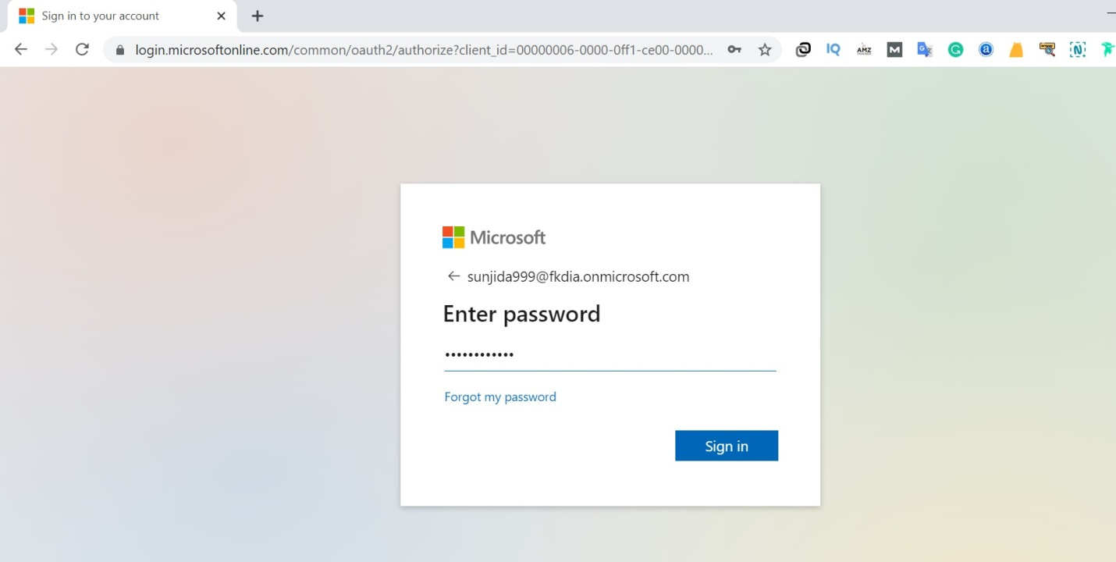

Figure 14.1: ask for password as email was matched, pressed Sign In

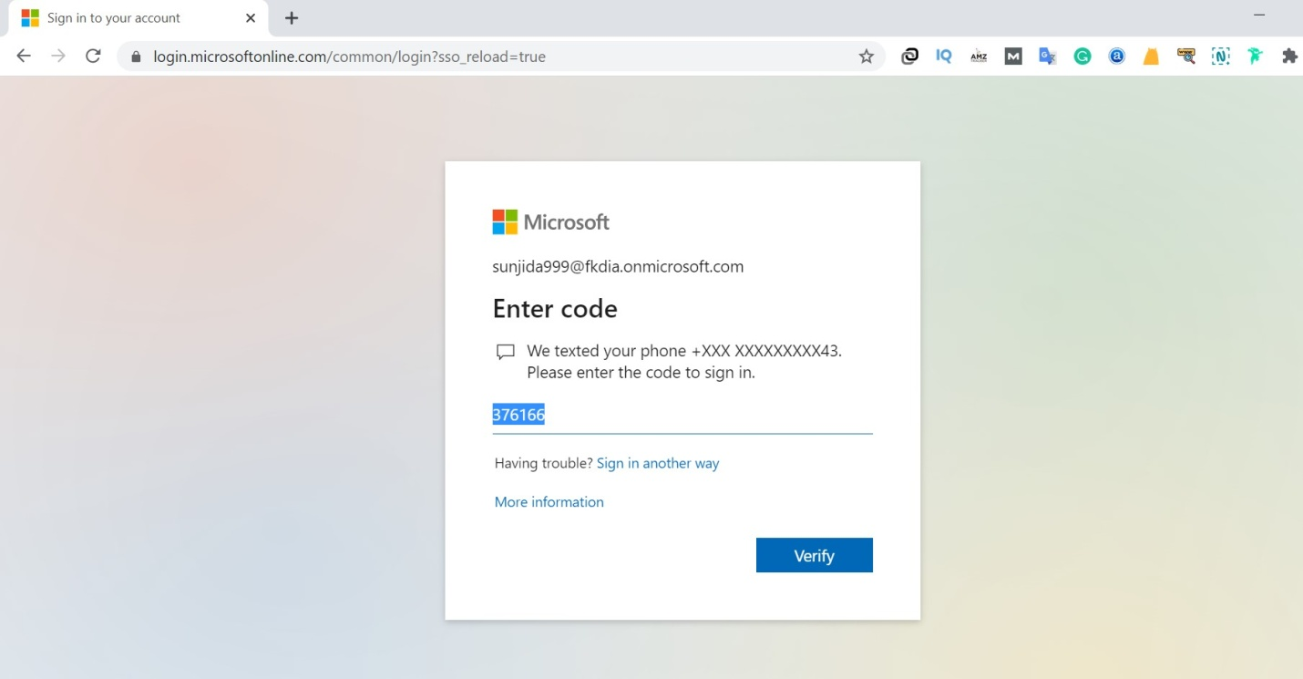

Figure 14.2: ask for the OTP sent to verified phone

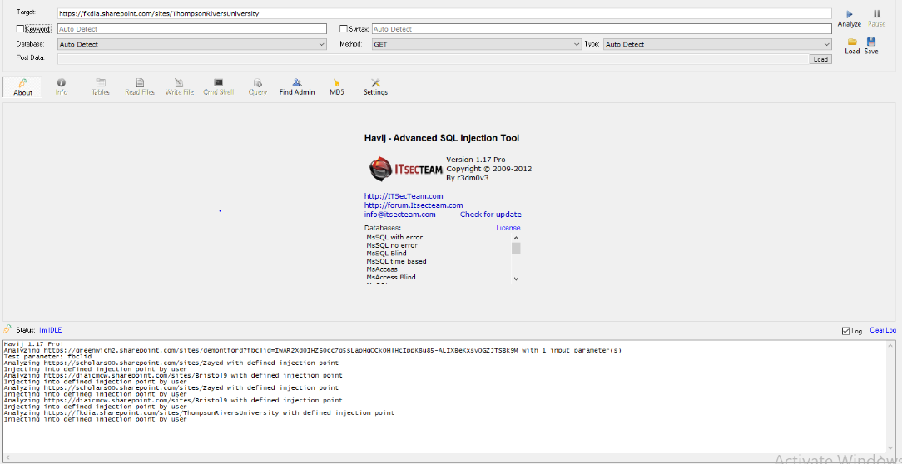

Figure 14.3: SQL injection test result.